Student Name:

Semester and today’s date:

Instructor:

Login to the Palo Alto Firewall via Secure Shell (SSH) method and practice the following commands to display the information. You can open the Terminal and type ssh -l admin 192.168.1.254 Then perform the screen capture of each output in each time you run the command following command.

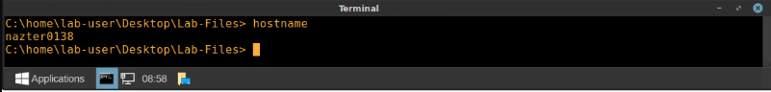

1. Show clock

Insert the screenshot here and explain what you see or understand.

Displays the current system time on the firewall

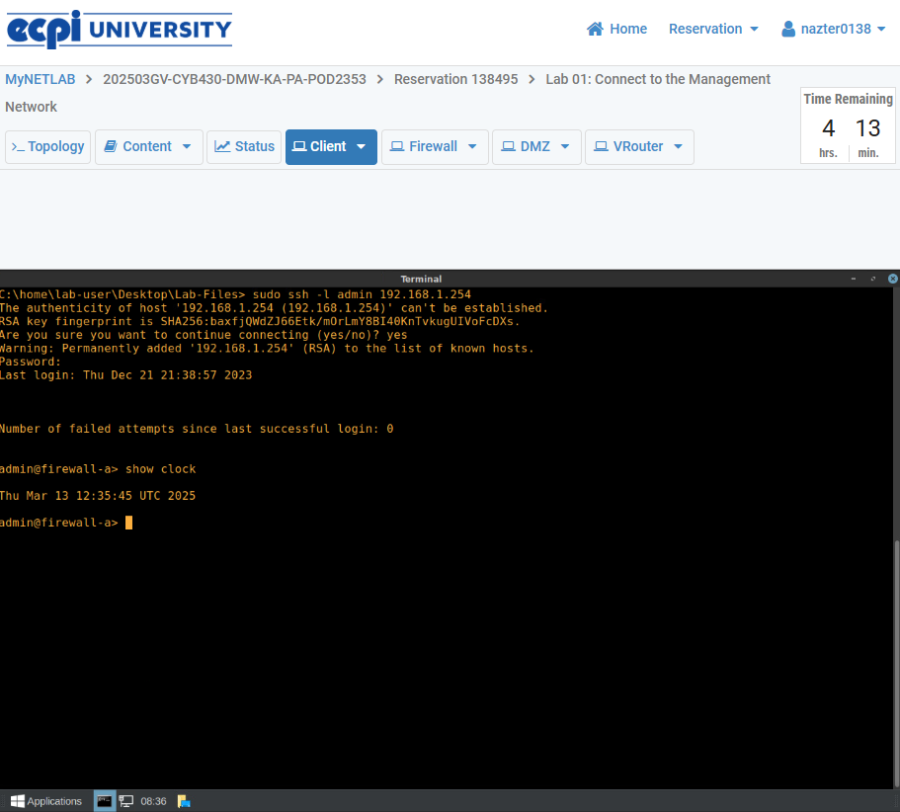

1. Show system info

Insert the screenshot here and explain what you see or understand.

Gives a summary of a systems basic information including the systems model, serial number, and firmware version

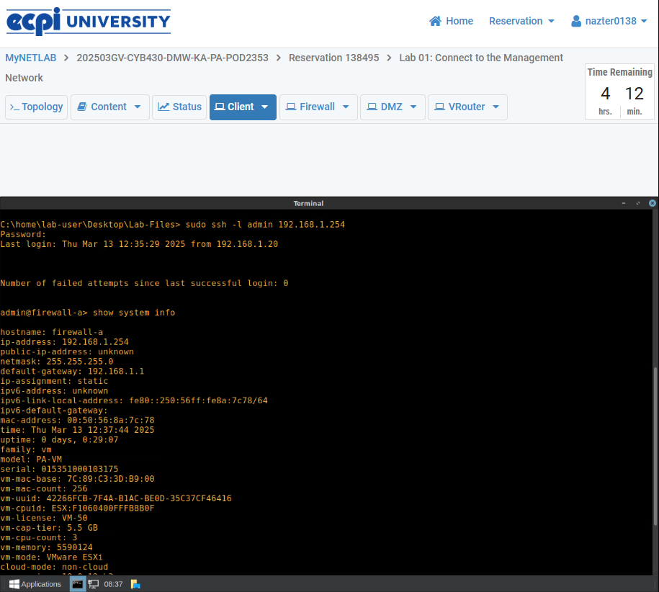

1. Ping host 8.8.8.8

Insert the screenshot here and explain what you see or understand.

Pings googles DNS server to check for connectivity

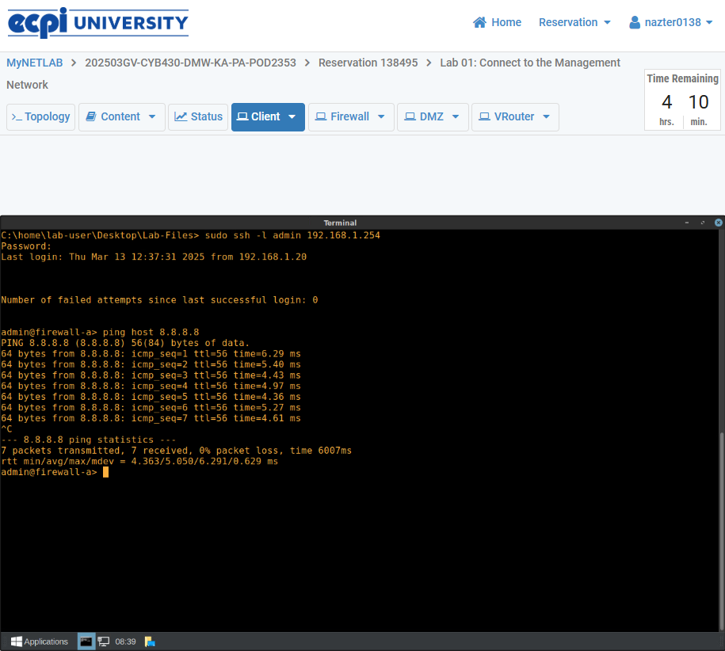

1. Traceroute host 8.8.8.8

Insert the screenshot here and explain what you see or understand.

Shows the path packets take to reach the desired destination. This can be used to help diagnose network issues

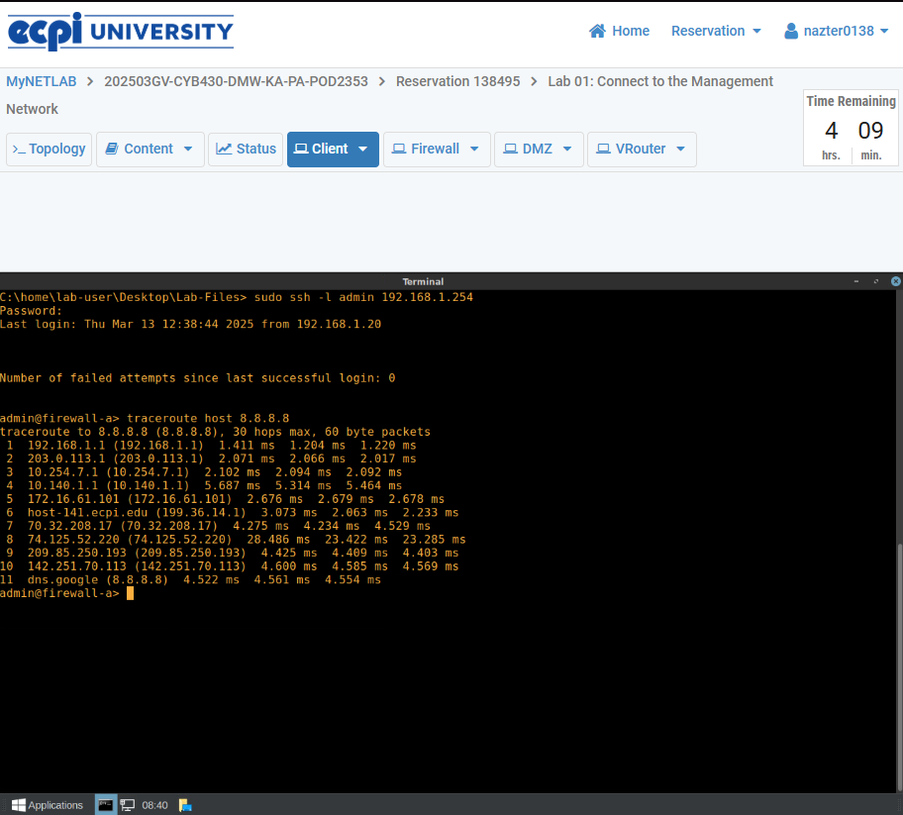

1. Show interface all

Insert the screenshot here and explain what you see or understand.

Shows all interface on firewall, including the operational status and statistics

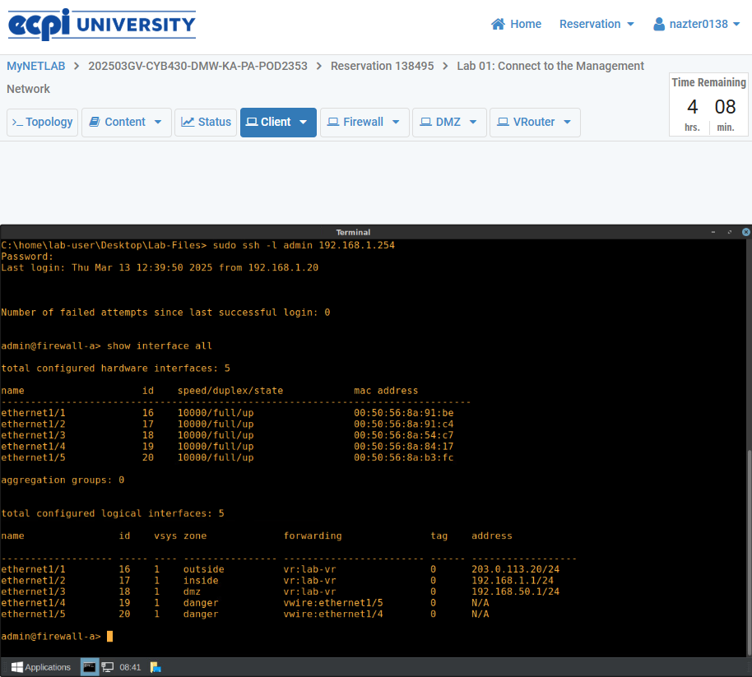

1. Show routing route

Insert the screenshot here and explain what you see or understand.

Displays firewalls routing table showing active routes and metrics

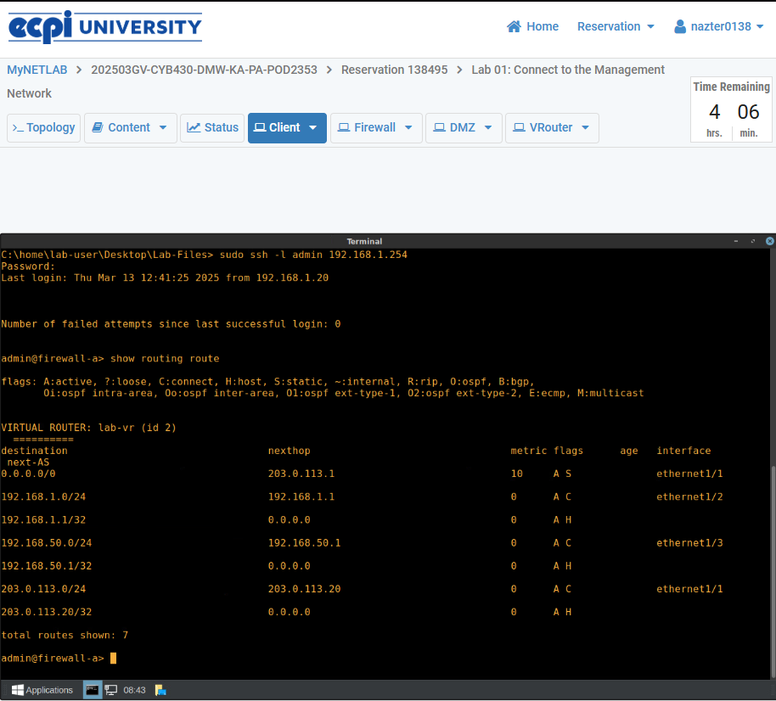

1. Show admins

Insert the screenshot here and explain what you see or understand.

Shows currently logged in admins of the firewall

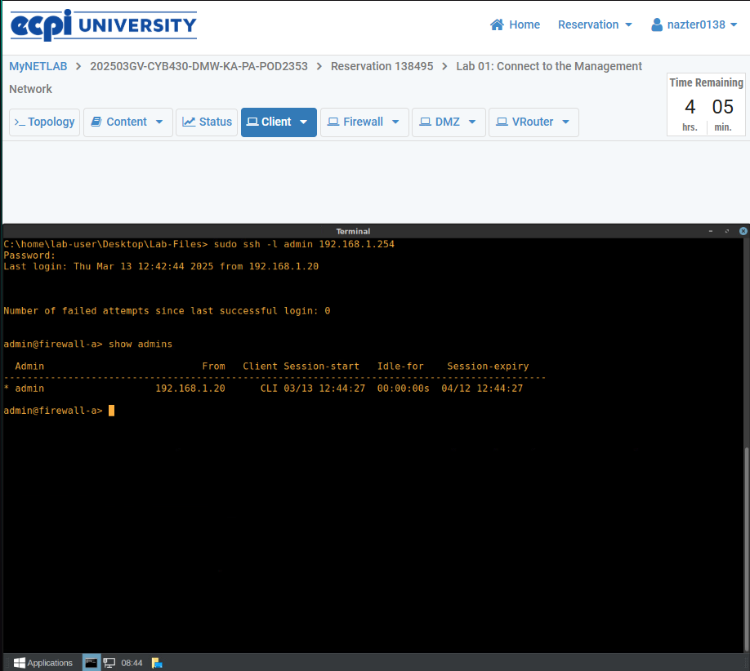

1. Show log system

Insert the screenshot here and explain what you see or understand.

Shows system logs, providing information about system events, errors, adn status changes

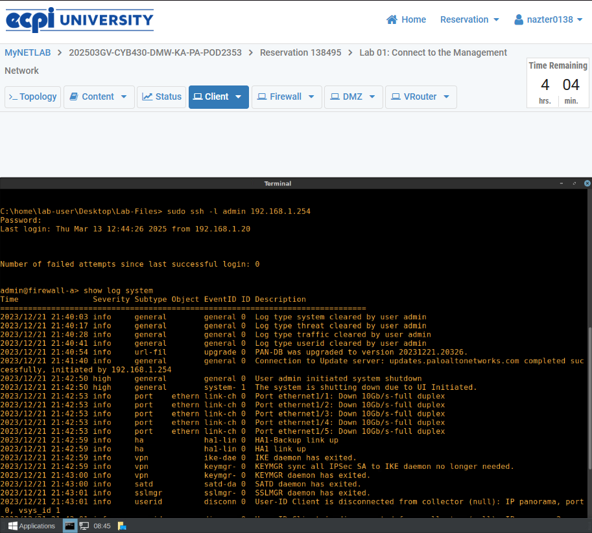

1. Show mac all

Insert the screenshot here and explain what you see or understand.

Shows all MAC addresses learned by the firewall

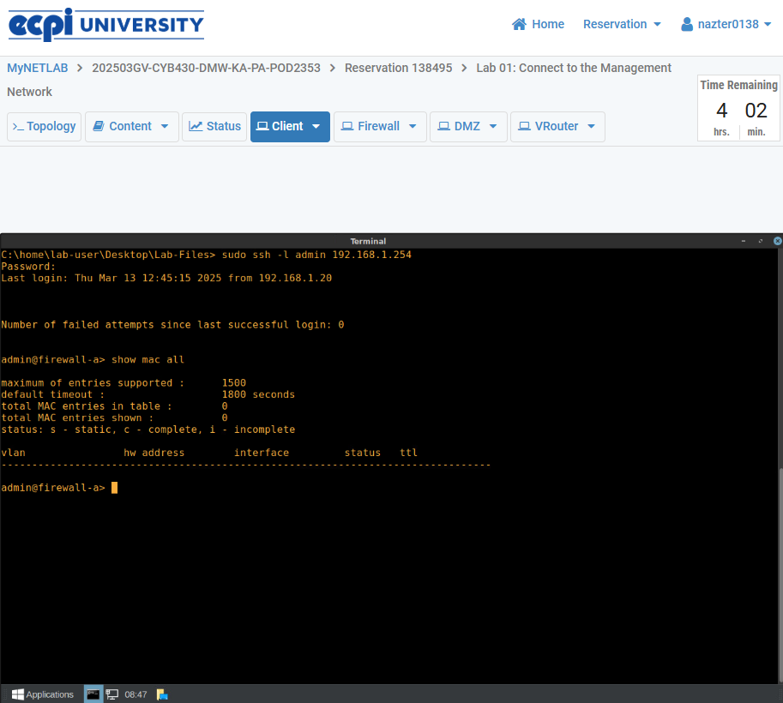

1. Show log traffic direction equal backward

Insert the screenshot here and explain what you see or understand.

Shows inbound traffic routes

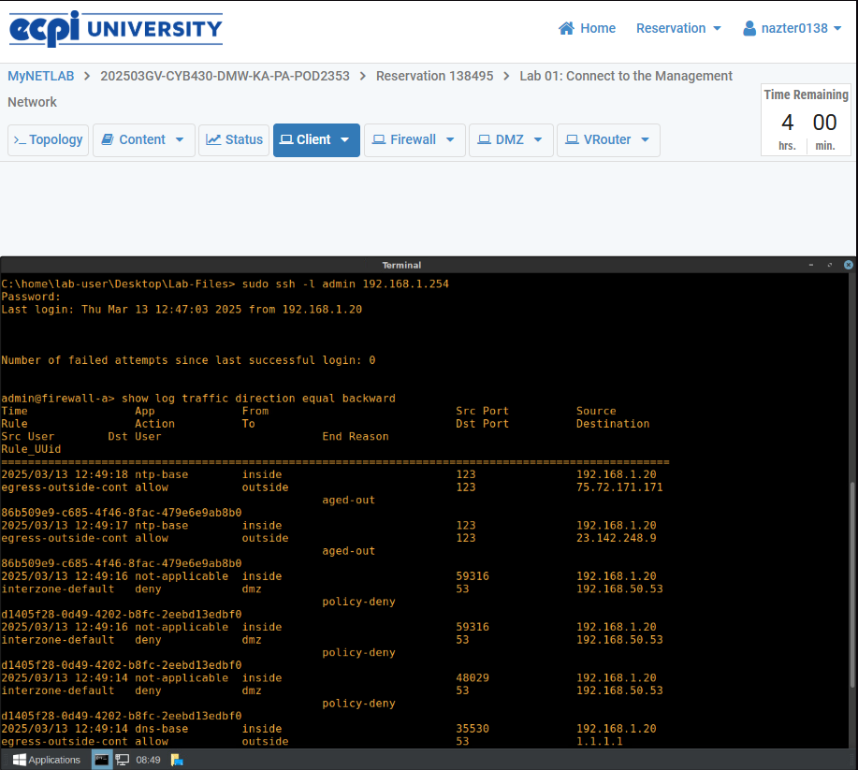

1. Request restart system

Insert the screenshot here and explain what you see or understand.

Restarts a firewalls system

